**SCRUM PROJECT MANAGEMENT SOFTWARE**

1. Conceptual model:

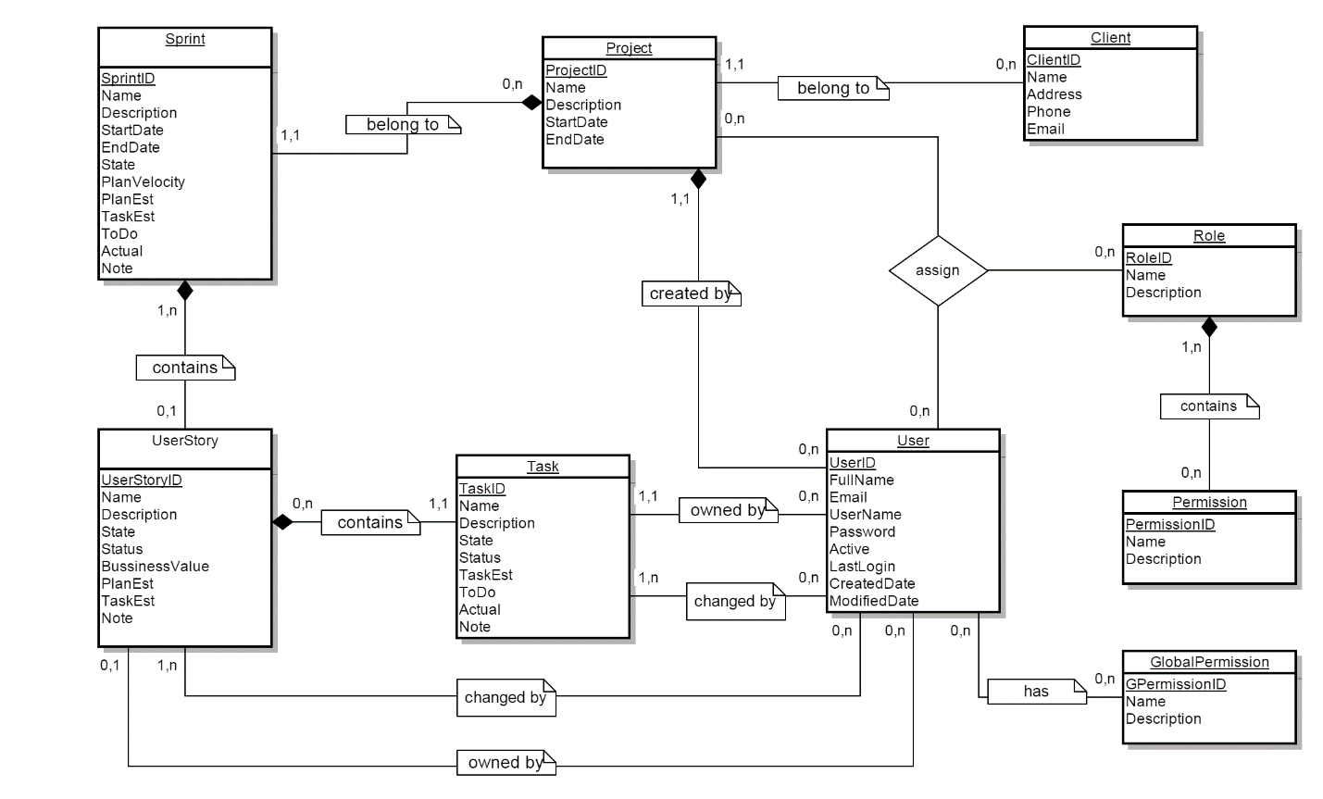

1. 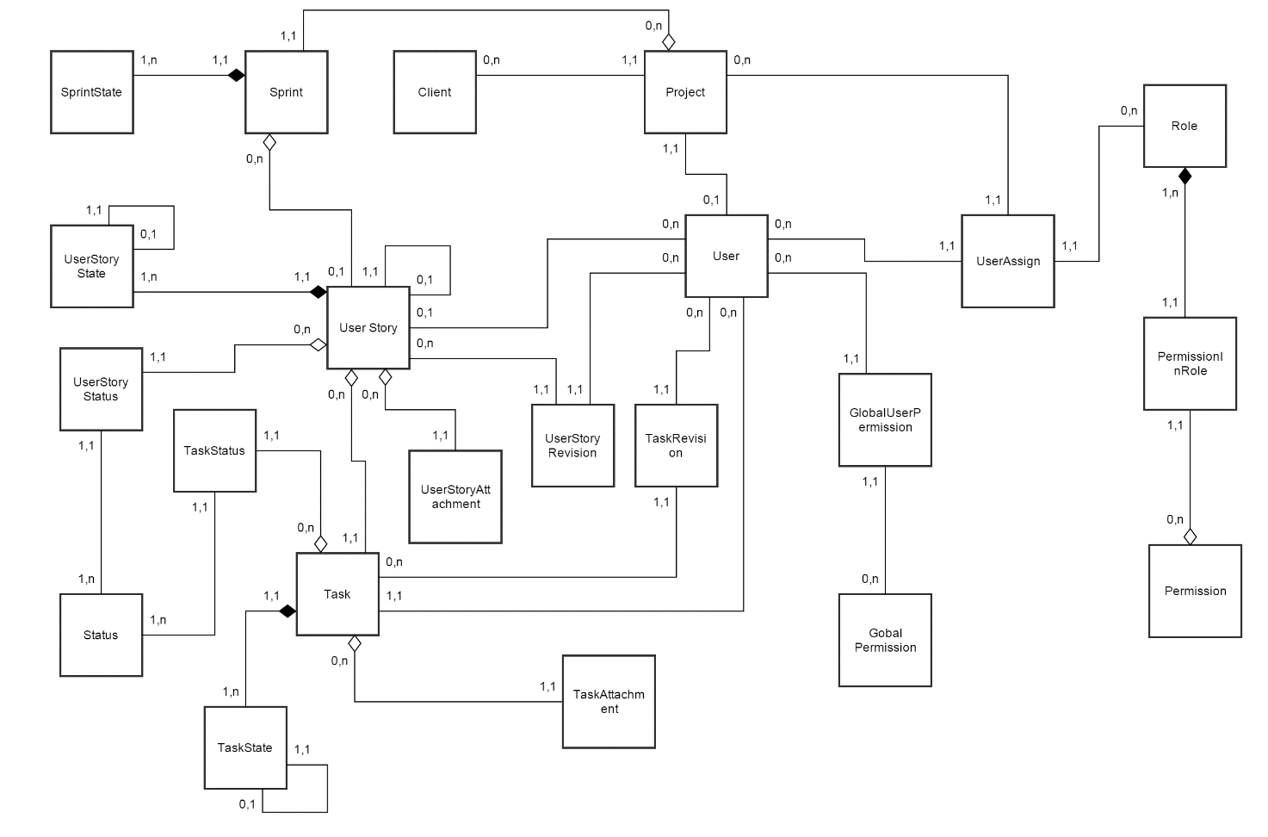Logical model:
2. Project management:

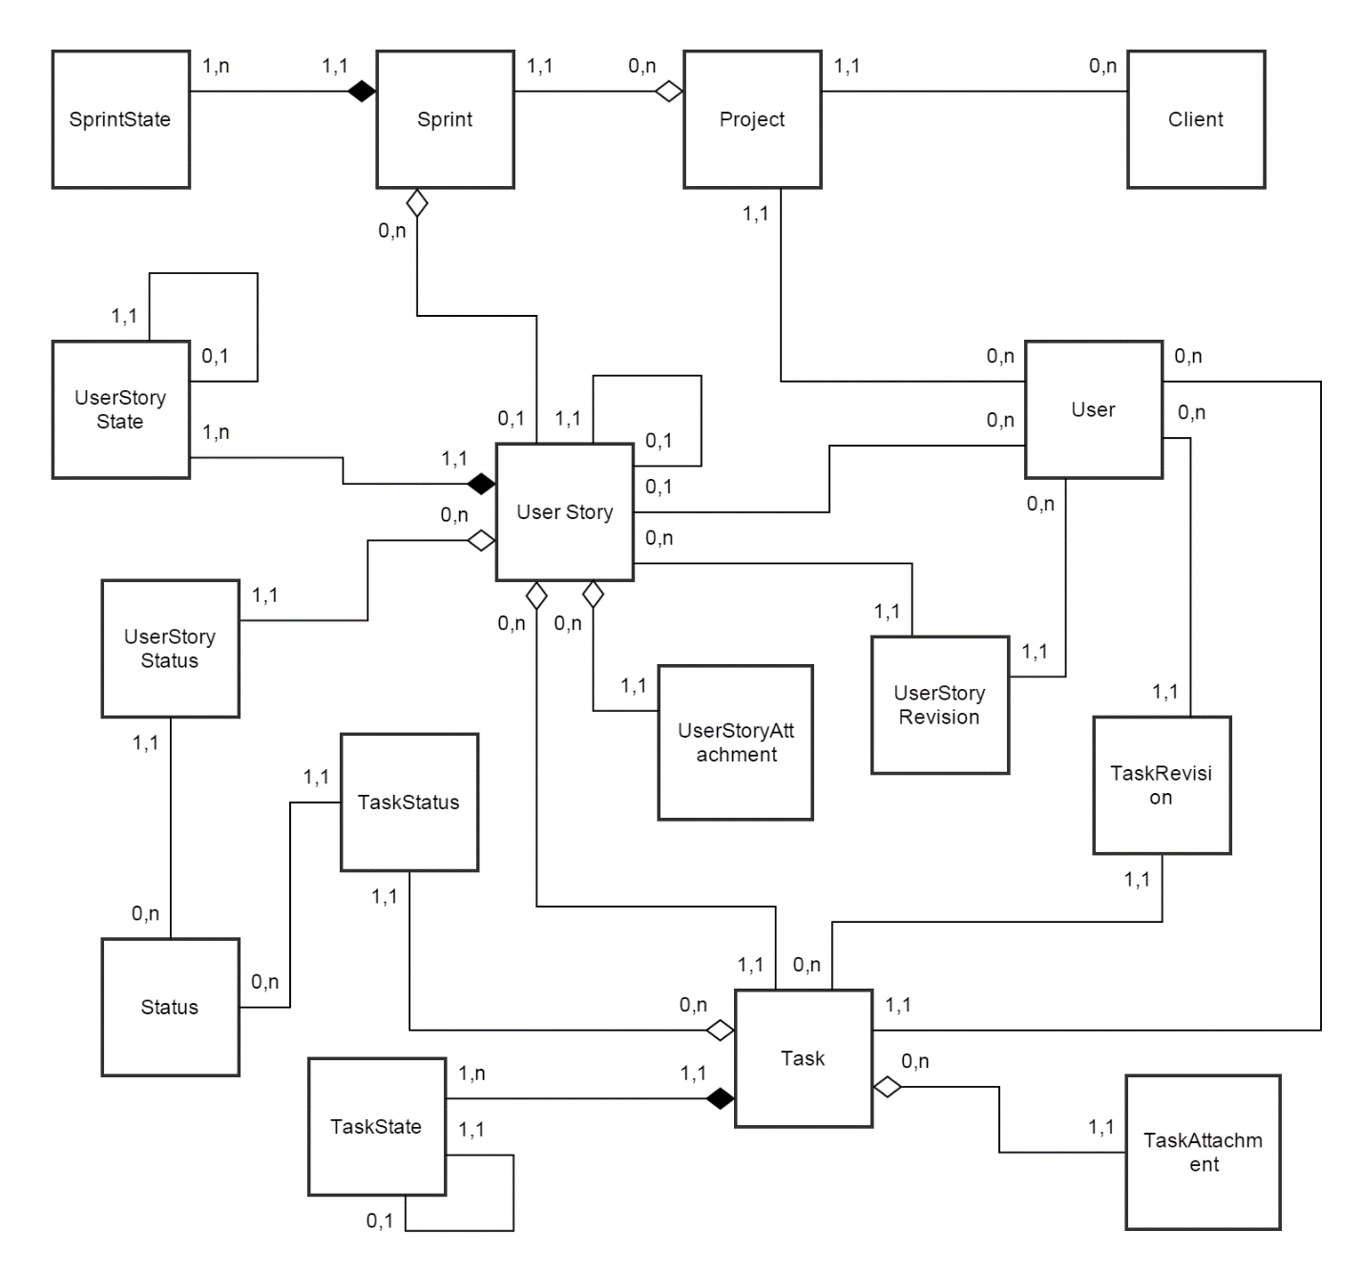

1. User management:

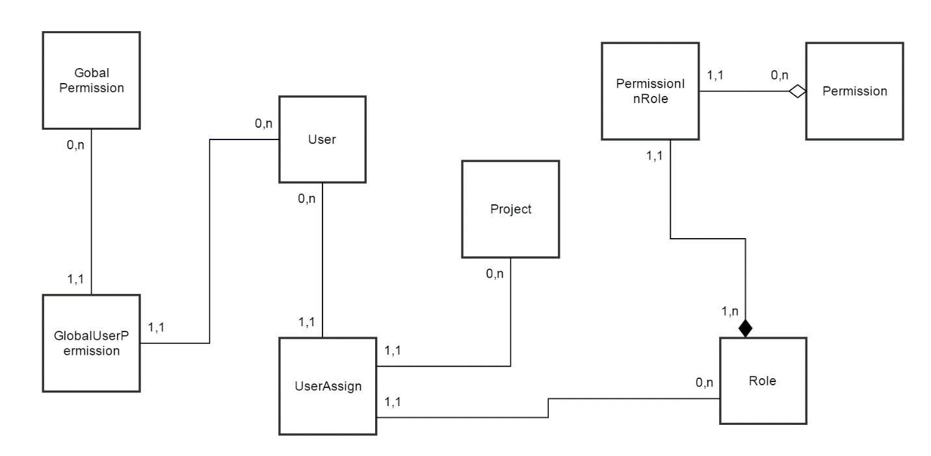

1. Tables:
2. Project:

|  |  |  |  |  |  |
| --- | --- | --- | --- | --- | --- |
| STT | Name | Type | Length | Null | Description |
| 1 | ProjectID | int |  | No | Project ID |
| 2 | Name | varchar | 100 | No | Name |
| 3 | Description | Text |  | Yes | Description |
| 4 | StartDate | DateTime |  | No | Start date |
| 5 | EndDate | DateTime |  | Yes | End date |
| 6 | ProjectOwner | int |  | No | Project owner |
| 7 | ClientID | int |  | Yes | Client ID |
| 8 | Active | Boolean |  | No | Active |

1. Sprint:

|  |  |  |  |  |  |
| --- | --- | --- | --- | --- | --- |
| STT | Name | Type | Length | Null | Description |
| 1 | SprintID | int |  | No | Sprint ID |
| 2 | Name | varchar | 100 | No | Name |
| 3 | Description | text |  | Yes | Description |
| 4 | StartDate | Datetime |  | No | Start date |
| 5 | EndDate | Datetime |  | Yes | End date |
| 6 | StateID | int |  | No | Sprint state ID |
| 7 | ProjectID | int |  | No | Project ID |
| 8 | PlanVelocity | Float |  | Yes | Plan Velocity |
| 9 | PlanEst | Float |  | Yes | Total Plans’ Estimate |
| 10 | TaskEst | Float |  | Yes | Total Tasks’ Estimate |
| 11 | Actuals | Float |  | Yes | Total Actual user stories |
| 12 | To Do | Float |  | Yes | Total to do user stories |
| 13 | Note | text |  | Yes | Note |
| 14 | Avtive | Boolean |  | No | Active |

1. SprintState:

|  |  |  |  |  |  |
| --- | --- | --- | --- | --- | --- |
| STT | Name | Type | Length | Null | Description |
| 1 | SprintStateID | int |  | No | Sprint state ID |
| 2 | Name | varchar | 100 | No | Name |
| 3 | Description | text |  | Yes | Description |

1. Client:

|  |  |  |  |  |  |
| --- | --- | --- | --- | --- | --- |
| STT | Name | Type | Length | Null | Description |
| 1 | ClientID | Int |  | No | Client ID |
| 2 | Name | Varchar | 100 | No | Name |
| 3 | Address | Varchar | 150 | Yes | Address |
| 4 | Phone | Varchar | 15 | Yes | Phone number |
| 5 | Email | Varchar | 100 | Yes | Email |
| 6 | StartDate | Datetime |  | No | Start date |
| 7 | EndDate | Datetime |  | Yes | End date |
| 8 | Active | Boolean |  | No |  |

1. UserStory:

|  |  |  |  |  |  |
| --- | --- | --- | --- | --- | --- |
| STT | Name | Type | Length | Null | Description |
| 1 | UserStoryID | Int |  | No | User Story ID |
| 2 | Name | Varchar | 100 | No | Name |
| 3 | Owner | Int |  | Yes | User Story’s Owner |
| 4 | ParentID | Int |  | Yes | Parent user story |
| 5 | SprintID | Int |  | Yes | Sprint ID |
| 6 | StateID | Int |  | No | User story state ID |
| 7 | BusinessValue | Int |  | Yes | Business value |
| 8 | PlanEst | Float |  | Yes | Plan estimate |
| 9 | TaskEst | Float |  | Yes | Total Tasks’ Estimate |
| 10 | ToDo | Float |  | Yes | Total tasks’ to do |
| 11 | Actual | Float |  | Yes | Total actual tasks |
| 12 | Note | Text |  | Yes | Note |
| 13 | ProjectID | Int |  | No | Project ID |
| 14 | Point | Float |  | Yes | Point |
| 15 | StartDate | Datetime |  | No | Start Date |
| 16 | EndDate | Datetime |  | Yes | End Date |
| 17 | Active | Boolean |  | Yes | Active |

1. UserStoryAttachment:

|  |  |  |  |  |  |
| --- | --- | --- | --- | --- | --- |
| STT | Name | Type | Length | Null | Description |
| 1 | USAttachmentID | Int |  | No | User story attachment ID |
| 2 | Name | Varchar | 100 | No | Name |
| 3 | FilePath | Varchar | 250 | No | File Path |
| 4 | UserStoryID | Int |  | No | User Story ID |
| 5 | Description | Text |  | Yes | Description |
| 6 | CreatedDate | datetime |  | No | Create date |

1. TaskAttachment:

|  |  |  |  |  |  |
| --- | --- | --- | --- | --- | --- |
| STT | Name | Type | Length | Null | Description |
| 1 | TaskAttachmentID | Int |  | No | Task attachment ID |
| 2 | Name | Varchar | 100 | No | Name |
| 3 | FilePath | Varchar | 250 | No | File Path |
| 4 | TaskID | Int |  | No | Task ID |
| 5 | Description | Int |  | Yes | Description |
| 6 | CreatedDate | datetime |  | No | Create date |

1. UserStoryState:

|  |  |  |  |  |  |
| --- | --- | --- | --- | --- | --- |
| STT | Name | Type | Length | Null | Description |
| 1 | USStateID | int |  | No | User story state ID |
| 2 | Name | varchar | 100 | No | Name |
| 3 | Description | text |  | Yes | Description |
| 4 | Parent | int |  | Yes | Parent state ID |

1. Status:

|  |  |  |  |  |  |
| --- | --- | --- | --- | --- | --- |
| STT | Name | Type | Length | Null | Description |
| 1 | StatusID | int |  | No | Sprint state ID |
| 2 | Name | varchar | 100 | No | Name |
| 3 | Description | text |  | Yes | Description |

1. UserStoryStatus:

|  |  |  |  |  |  |
| --- | --- | --- | --- | --- | --- |
| STT | Name | Type | Length | Null | Description |
| 1 | StatusID | Int |  | No | Status ID |
| 2 | UserStoryID | Int |  | No | User story ID |

1. TaskStatus:

|  |  |  |  |  |  |
| --- | --- | --- | --- | --- | --- |
| STT | Name | Type | Length | Null | Description |
| 1 | StatusID | Int |  | No | Status ID |
| 2 | TaskID | Int |  | No | Task ID |

1. Task:

|  |  |  |  |  |  |
| --- | --- | --- | --- | --- | --- |
| STT | Name | Type | Length | Null | Description |
| 1 | TaskID | Int |  | No | Task ID |
| 2 | Name | Varchar | 100 | No | Name |
| 3 | StateID | Int |  | No | Task State ID |
| 4 | TaskEst | Float |  | Yes | Task estimation (hour) |
| 5 | ToDo | Float |  | Yes | To Do (hour) |
| 6 | Actual | Float |  | Yes | Actual time (hour) |
| 7 | Note | Text |  | Yes | Note |
| 8 | Owner | Int |  | Yes | Owner ID |
| 9 | ProjectID | Int |  | No | Project ID |
| 10 | StartDate | Datetime |  | No | Start Date |
| 11 | EndDate | EndDate |  | Yes | End Date |
| 12 | Active | Boolean |  | Yes | Active |

1. TaskState:

|  |  |  |  |  |  |
| --- | --- | --- | --- | --- | --- |
| STT | Name | Type | Length | Null | Description |
| 1 | TaskStateID | int |  | No | Task state ID |
| 2 | Name | varchar | 100 | No | Name |
| 3 | Description | text |  | Yes | Description |
| 4 | Parent | int |  | Yes | Parent state ID |

1. UserStoryRevision:

|  |  |  |  |  |  |
| --- | --- | --- | --- | --- | --- |
| STT | Name | Type | Length | Null | Description |
| 1 | RevisionID | Int |  | No | Revision ID |
| 2 | Description | Text |  | No | Description |
| 3 | AuthorID | Int |  | No | Author ID |
| 4 | UserStoryID | Int |  | No | User story ID |
| 5 | CreatedDate | Datetime |  | No | Created date |

1. TaskRevision:

|  |  |  |  |  |  |
| --- | --- | --- | --- | --- | --- |
| STT | Name | Type | Length | Null | Description |
| 1 | RevisionID | Int |  | No | Revision ID |
| 2 | Description | Text |  | No | Description |
| 3 | AuthorID | Int |  | No | Author ID |
| 4 | TaskID | Int |  | No | Task ID |
| 5 | CreatedDate | Datetime |  | No | Created date |

1. User:

|  |  |  |  |  |  |
| --- | --- | --- | --- | --- | --- |
| STT | Name | Type | Length | Null | Description |
| 1 | UserID | Int |  | No | User ID |
| 2 | FullName | Varchar | 250 | No | Full name |
| 3 | Email | Varchar | 100 | No | Email |
| 4 | Username | Varchar | 100 | No | User name |
| 5 | Password | Varchar | 100 | Yes | Password |
| 6 | Active | Boolean |  | No | Active state |
| 7 | LastLogin | Datetime |  | Yes | Last login |
| 8 | CreatedDate | Datetime |  | No | Created date |
| 9 | CreatedByUserID | Int |  | No | Created user |

1. GlobalPermission:

|  |  |  |  |  |  |
| --- | --- | --- | --- | --- | --- |
| STT | Name | Type | Length | Null | Description |
| 1 | GPermissionID | Int |  | No | Global Permission ID |
| 2 | Name | Varchar | 100 | No | Name |
| 3 | Description | Text |  | Yes | Description |

1. GlobalUserPermission:

|  |  |  |  |  |  |
| --- | --- | --- | --- | --- | --- |
| STT | Name | Type | Length | Null | Description |
| 1 | GPermissionID | Int |  | No | Global Permission ID |
| 2 | UserID | Int |  | No | User ID |
| 3 | StartDate | Datetime |  | No | Start date |

1. Permission:

|  |  |  |  |  |  |
| --- | --- | --- | --- | --- | --- |
| STT | Name | Type | Length | Null | Description |
| 1 | PermissionID | Int |  | No | Permission ID |
| 2 | Name | Varchar | 100 | No | Name |
| 3 | Description | Text |  | Yes | Description |

1. PermissionInRole:

|  |  |  |  |  |  |
| --- | --- | --- | --- | --- | --- |
| STT | Name | Type | Length | Null | Description |
| 1 | PermissionID | Int |  | No | Permission ID |
| 2 | RoleID | Int |  | No | Role ID |

1. Role:

|  |  |  |  |  |  |
| --- | --- | --- | --- | --- | --- |
| STT | Name | Type | Length | Null | Description |
| 1 | RoleID | Int |  | No | Role ID |
| 2 | Name | Varchar | 100 | No | Name |
| 3 | Description | Text |  | Yes | Description |
| 4 | CreatedDate | Datetime |  | No | Created date |

1. UserAssign:

|  |  |  |  |  |  |
| --- | --- | --- | --- | --- | --- |
| STT | Name | Type | Length | Null | Description |
| 1 | UserAssignID | Int |  | No | User assign ID |
| 2 | UserID | Int |  | No | User ID |
| 3 | RoleID | Int |  | No | Role ID |
| 4 | ProjectID | Int |  | No | Project ID |
| 5 | StartDate | Datetime |  | No | Start date |
| 6 | EndDate | Datetime |  | No | End date |
| 7 | Retire | Boolean |  | Yes | Retire |